HANDS-ON : 1

Step 1: Setup your machine with Git Configuration
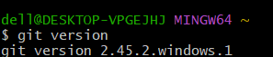
To check if Git client is installed properly

To configure user level configuration of user ID and email ID execute

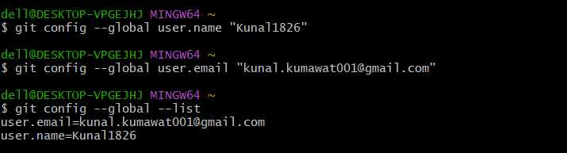

Step 2: Integrate notepad++.exe to Git and make it a default editor

Notepad++ will show the entire global configuration
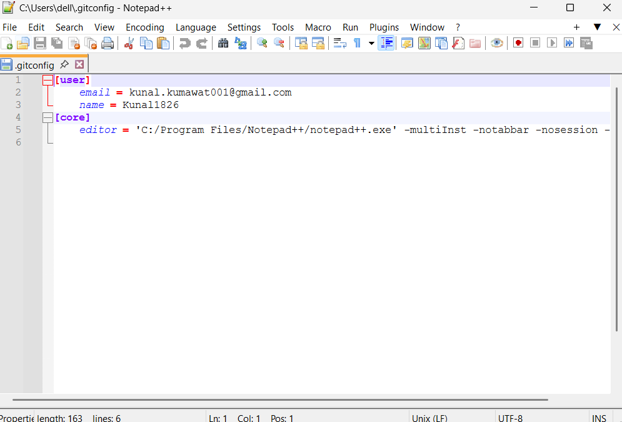
Step 3: Add a file to source code repository
- Open Git bash shell and create a new project “GitDemo” by executing the command
- Git bash initializes the “GitDemo” repository. To verify, execute the command
- To create a file “welcome.txt” and add content to the file, execute the command
- Check the status , Now the file “welcome.txt” is available in Git “working directory”
- To make the file to be tracked by Git repository, execute the command
- To add multi line comments, we are opening default editor to comment. Execute the command
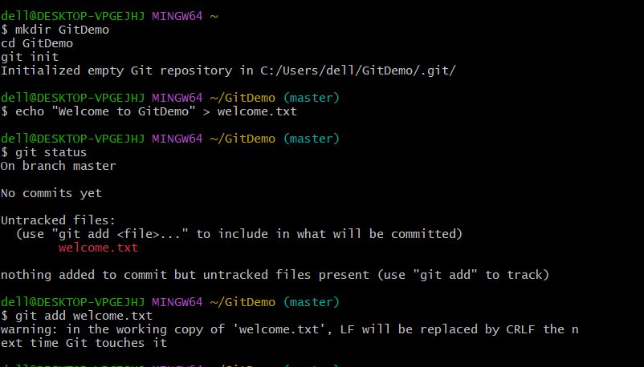
- To check if local and “Working Directory” git repository are same, execute git status
welcome.txt is added to the local repository.

- Signup with GitLab and create a remote repository “GitDemo”
- To pull the remote repository, execute git pull origin master

- To push the local to remote repository, execute git push origin master

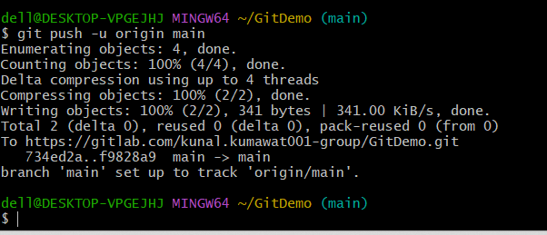

OUTPUT

